**Excel Assignment – 9**

1. **What are the different margins options and do we adjust the margins of the excel worksheet?**

Ans :- Margins Option :- Right, Left, Top, Bottom.

1. Click on the page layout,
2. Click on the Margins Button
3. Select the appropriate size as per the conditions.
4. **Set a background for your table created.**

Ans :-

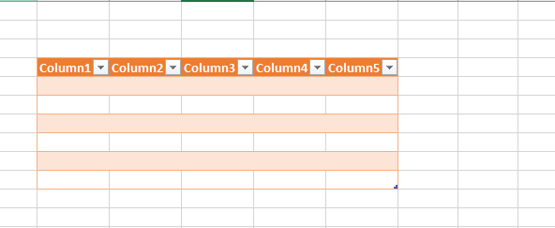

1. **What is freeze panes and why do we use freeze panes? Give**

**examples.**

Ans :- To keep a area of a worksheet visible while you scroll to another area of the worksheet.

Eg:-1) Freeze pane can use to freeze the headers of the tables.

2) Can freeze the age criteria column to scroll up when the data is in huge demand.

1. **What are the different features available within the Freeze Panes command?**

Ans:-

1. Freeze Panes
2. Freeze Top Row
3. Freeze First Column
4. **Explain what the different sheet options present in excel are and what they do?**

Ans :- 1) Ribbon Sheet Option

2) Page Layout – Sheet Options

1- Print Area

2- Print Titles

3- Print

1. Gridlines
2. Black & White

4- Page Order